Traditional Thesaurus

What is Traditional Thesaurus
# Source: AI Source: Provided by: [Data Path: Persons Table -> ID Column: 1, Name_En Column: Motasem Essam] -> From: [Chatgpt (GPT-4-turbo)] on [7/29/2025]
A Traditional Thesaurus is a reference book or resource that lists synonyms (and often antonyms) of words, organized in a way that helps users find alternative expressions based on meaning. This classic format focuses on grouping words by concept or semantic category rather than alphabetically.

🔹 Key Features of a Traditional Thesaurus
# Source: AI Source: Provided by: [Data Path: Persons Table -> ID Column: 1, Name_En Column: Motasem Essam] -> From: [Chatgpt (GPT-4-turbo)] on [7/29/2025]
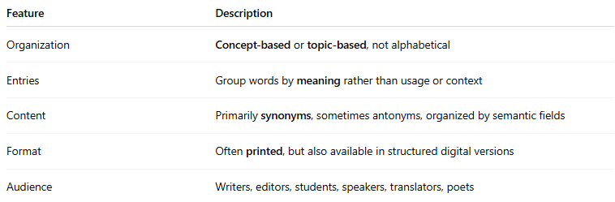
Feature | Description
Organization | Concept-based or topic-based, not alphabetical
Entries | Group words by meaning rather than usage or context
Content | Primarily synonyms, sometimes antonyms, organized by semantic fields
Format | Often printed, but also available in structured digital versions
Audience | Writers, editors, students, speakers, translators, poets

🔹 Classic Examples
# Source: AI Source: Provided by: [Data Path: Persons Table -> ID Column: 1, Name_En Column: Motasem Essam] -> From: [Chatgpt (GPT-4-turbo)] on [7/29/2025]
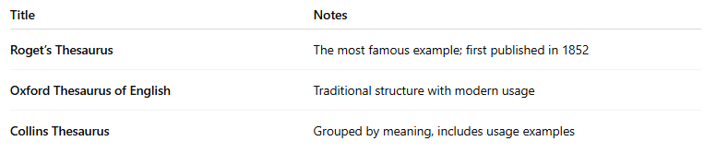
Title | Notes
Roget’s Thesaurus | The most famous example; first published in 1852
Oxford Thesaurus of English | Traditional structure with modern usage
Collins Thesaurus | Grouped by meaning, includes usage examples

🔹 How It Works
# Source: AI Source: Provided by: [Data Path: Persons Table -> ID Column: 1, Name_En Column: Motasem Essam] -> From: [Chatgpt (GPT-4-turbo)] on [7/29/2025]
- Words are grouped under broad conceptual categories like emotion, movement, intelligence, etc.
- The user searches by idea rather than a specific word.
- Entries list sets of related words with slight or nuanced differences in meaning.

🔹 Advantages
# Source: AI Source: Provided by: [Data Path: Persons Table -> ID Column: 1, Name_En Column: Motasem Essam] -> From: [Chatgpt (GPT-4-turbo)] on [7/29/2025]
- Encourages rich vocabulary and precise word choice
- Promotes semantic awareness (grouping ideas, not just words)
- Helpful in writing, speaking, and translation

🔹 Limitations
# Source: AI Source: Provided by: [Data Path: Persons Table -> ID Column: 1, Name_En Column: Motasem Essam] -> From: [Chatgpt (GPT-4-turbo)] on [7/29/2025]
- May not always reflect modern usage or contextual nuance
- Requires some familiarity with conceptual navigation
- Less user-friendly for those looking for a quick alphabetical lookup (compared to modern thesauruses)

